IN723 Lab 8 BGP Integrated

In this lab we will configure a dual homed site utilizing features of BGP, OSPF, HSRP, STP and Etherchannel. Each site will be connected to a common hub site for interconnectivity.
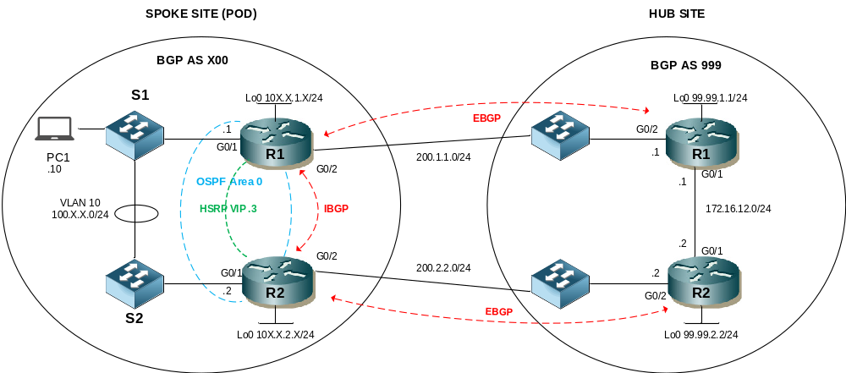

- Note – This lab cannot be completed in packet tracer (unsupported BGP commands). This lab is designed for multiple physical labs (pods) connected to a single hub.
- You may need to clear BGP sessions or issue a soft reset for some changes to take effect

Step 1 - Physical
- Physically cable the lab as per the above diagram using 1841 / 1941 routers, 2960 switches and Ethernet straight through and crossover cables.

Step 2 – IP addressing
- Configure IP addressing as per the following table where X = your pod number
- Ensure the interfaces are not shutdown

Interface | IP Address | Default Gateway
R1 G0/0 | 100.X.X.1/24
R1 G0/1 | 200.1.1.X1/24
R1 Lo0 | 10X.X.1.X/24
R2 G0/0 | 100.X.X.2/24
R2 G0/1 | 200.2.2.X2/24
R2 Lo0 | 10X.X.2.X/24
PC1 | 100.X.X.10/24 | 100.X.X.3

Step 3 – Configure Layer 2
- Configure S1 & S2 to use Rapid PVST+ spanning tree
- Configure R1 as the root bridge
- Configure etherchannel using LACP for the 2 ethernet links between S1 and S2
- Ensure the etherchannel is not negotiated
- Configure the etherchannel as a Trunk that will only carry VLANs 1 & 10
- Ensure the trunk is non negotiable
- Configure the PC1 user port in VLAN 10
- Configure the ports for R1 & R2 in VLAN 10
- Ensure all user ports will transition to forwarding immediately.

Step 4 – HSRP
- Configure an HSRP standby group on R1 and R2 for the VLAN 10 network

Group | VIP | Priority R1 | Priority R2
For VLAN 10 | 100.X.X.3/24 | 105 | 100 (default)

- Ensure the routers can preemptively take control if they have a higher priority
- Ensure that HSRP tracks the state of the WAN interface on R1 and R2 and will decrement the standby priority by 10 (default) if it goes down

Step 5 – Configure OSPF
- Configure OSPF on R1 & R2 to use the loopback IP address as the router ID
- Ensure that OSPF can calculate costs for gigabit links less than 100mb
- Ensure R1 is elected DR for the multi access LAN segment between R1 and R2
- Activate OSPF on the router LAN interfaces in AREA 0
- Advertise the loopbacks of R1 & R2 as OSPF internal routes

Step 6 – BGP Peering
- Configure the local BGP AS in the format X00, where is your pod number (e.g pod 2 = 200)
- Configure fixed BGP router-ids on R1, R2 using the loopback IP addresses
- Configure IBGP between R1 and R2 using the loopback interfaces for peering.
- Configure EBGP between R1 and the hub sites R1 using the WAN interfaces for peering
- Configure EBGP between R2 and the hub sites R2 using the WAN interfaces for peering
- Ensure next-hop-self is set for prefixes advertised between R1 and R2

Step 7 – Advertise Networks
- Advertise the LAN network (VLAN 10). Ensure the origin code is i
- Advertise the loopback networks of R1 & R2. Ensure the origin code is ?. Use a route-map to ensure only the loopbacks are advertised this way

Step 8 – BGP Policy
- Use the aggregate-address command on R1 and R2 to advertise a single summary representing both loopback addreses. Ensure the specifics are suppressed
- Configure the summary prefix with the community no-export to ensure it is not advertised beyond the hub site
- Configure BGP so that R1s WAN link to is the preferred path for all outbound traffic destined outside your AS
- Configure BGP so that R1s WAN link to is the preferred path for all inbound traffic to your AS

Step 9 – Testing
- Ensure all PCs can ping each other
- Confirm your routers loopback networks are not present in other spoke site routing / BGP tables
- Confirm R1 is the primary path out of your AS
- Confirm R1 is the primary path into your AS
- Disable your link from R1 to the hub site. Ensure your PC can still ping other PCs

HUB Site
iBGP between R1 & R2 w/ next-hop-self
neighbor 172.16.12.1 remote-as 999
neighbor 172.16.12.1 next-hop-self

neighbor 172.16.12.2 remote-as 999
neighbor 172.16.12.2 next-hop-self

eBGP peering on R1 to:
neighbor 200.1.1.11 remote-as 100
neighbor 200.1.1.21 remote-as 200
neighbor 200.1.1.31 remote-as 300
neighbor 200.1.1.41 remote-as 400

eBGP peering on R2 to:
neighbor 200.1.1.12 remote-as 100
neighbor 200.1.1.22 remote-as 200
neighbor 200.1.1.32 remote-as 300
neighbor 200.1.1.42 remote-as 400

